Trophic Interactions in the Kelp Forest

An Ecological Detective Story

Name _____________________________________________________

**Kelps** are large brown marine algae that grow in extensive stands that reach the ocean’s surface and form a floating canopy. Kelp forests provide shelter and food for at least 750 species of animals and plants. Fish hide among kelp fronds to avoid predators, and search for smaller prey. The tall fronds rising to the surface provide substrate and protection for many invertebrate species. Others, like sea urchins and abalone, dine on the kelp blades. High-level predators also hunt for food in this species-rich and highly productive ecosystem.

Like many ecosystems, the health of the kelp forest depends on a delicate balance between the organisms that make it their home. One of the important players in kelp forest ecosystems is the sea otter, *Enhydra lutris*,a small marine mammal that acts as a **keystone** **species** in this habitat. Without otters, marine herbivores – in particular, sea urchins - over-graze and destroy the kelp. In turn, this causes the ecosystem to collapse in a **trophic** **cascade** that affects a wide array of species.

This is exactly what happened to kelp forests along the coastlines of the Pacific Rim in the early 20th century. Otters were hunted extensively for their pelts, driving an estimated global population of as many as 300,000 individuals down to a mere 2,000 by 1911. In California, otters were extirpated except for a remnant population of 50 animals near Big Sur. With the disappearance of otters, kelp forest ecosystems collapsed, becoming urchin “barrens.”

**In the space at right, draw a simple diagram to illustrate the top-down effect of otters on urchins and kelp. Use one arrow style for the bottom-up energy flow, and another to represent the top-down control from predators.**

**Q: According to the top-down theory, what is the effect of a loss of otters on sea urchin populations?**

**Q: What, in turn, is the effect on kelp?**

Fortunately, otters were given protection in 1911 under the International Fur Seal Treaty. Over the next several decades, sea otter populations recovered to about 150,000 individuals, occupying about two-thirds of their former range once again.

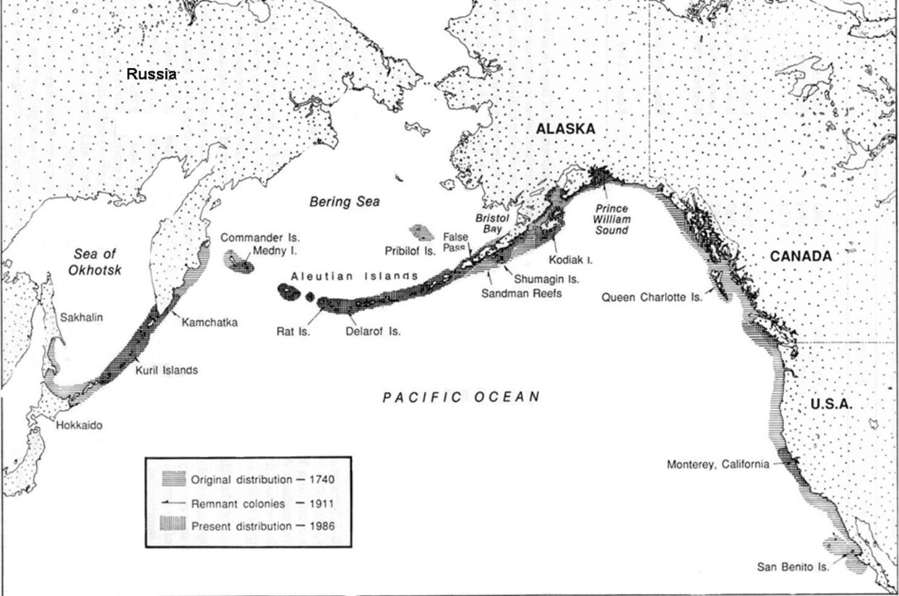

**Construct a food web for the Kelp Forest Ecosystem**. You will be given a set of cards that describe some of the organisms in this ecosystem. Use the cards to fill in the chart below. Then, you can use this information to draw a food web chart on the white board.

|  |  |  |  |  |  |  |  |  |  |  |  |  |  |
| --- | --- | --- | --- | --- | --- | --- | --- | --- | --- | --- | --- | --- | --- |
|  |  | Sources of Food  (Who is getting eaten) | | | | | | | | | | | |
|  |  | Bald Eagle | Baleen Whales | Gulls | Harbor Seal | Herring | Kelp | Orca (Transient) | Phytoplankton | Zooplankton | Sea Otter | Sea Urchin | Steller’s Sea Lion |
| Producers and Consumers  (Who is doing the eating) | Bald Eagle |  |  |  |  |  |  |  |  |  |  |  |  |
| Baleen Whales |  |  |  |  |  |  |  |  |  |  |  |  |
| Gulls |  |  |  |  |  |  |  |  |  |  |  |  |
| Harbor Seal |  |  |  |  |  |  |  |  |  |  |  |  |
| Herring |  |  |  |  |  |  |  |  |  |  |  |  |
| Kelp |  |  |  |  |  |  |  |  |  |  |  |  |
| Orca (Transient) |  |  |  |  |  |  |  |  |  |  |  |  |
| Phytoplankton |  |  |  |  |  |  |  |  |  |  |  |  |
| Zooplankton |  |  |  |  |  |  |  |  |  |  |  |  |
| Sea Otter |  |  |  |  |  |  |  |  |  |  |  |  |
| Sea Urchin |  |  |  |  |  |  |  |  |  |  |  |  |
| Steller’s Sea Lion |  |  |  |  |  |  |  |  |  |  |  |  |

Note: This is an extremely **simplified** matrix that does not include all food sources for each of these groups, or all relationships between the groups included here. For example, squid (not listed) are an important food source for sea lions, and otters eat more than just sea urchins.

**Q: Who are the producers in this system? How can you tell by looking at the matrix?**

**Q: Who are the top predators in this system? How can you tell by looking at the matrix?**

**Q: What is the difference between phytoplankton and zooplankton? Are they producers, or consumers?**

Instructions for constructing food web chart:

* Include **two distinctive sets of arrows:**
  + One set to show the flow of energy through the system
  + A second set that reflects the top-down pressures being exerted by the main players in the system: **orcas, sea otters, sea urchins, and kelp.**
* Draw the boxes in your chart according to the following **color scheme**:
  + Green = producers
  + Blue = primary consumers
  + Purple = secondary consumers
  + Red = tertiary or higher-level consumers

Sketch your finished food web in the space below:

While sea otter populations were able to recover in many areas, in the 1990s, they began to decline again in some areas, for reasons that weren’t readily apparent. Dr. James Estes, a marine ecologist with the U.S. Geological Survey, began to investigate this question, and found that on some Alaskan islands, otter numbers had plummeted by as much as 90 percent in fewer than 10 years. What factors could contribute to such a rapid change in the size of sea otter populations? Estes and his team set out to discover the culprit. You will explore the findings of this research in this assignment, but first, take a few minutes to think through the following questions, and write your answer below:

**Q: Is it reasonable to spend federal tax dollars to support scientific research into the decline of otter populations? Are we wasting money on animals that are merely “cute and fuzzy,” or might the loss of sea otters be an indicator (or even a cause) of more widespread imbalanced of these marine ecosystems?**

In this excerpt from a New York Times article, Estes offers some clues to which factors were probably *not* causing the recent declines in sea otters:

Could the otters simply have migrated from one part of the region to another? To find out, the researchers analyzed populations over a 500-mile-long stretch of the Aleutians .... By 1993 otter numbers in that whole stretch had been cut by half. Here the geographical scope of the research effort became critical; a smaller region would not have been large enough to reveal the decline. In 1997, they ... found that the population decline had worsened, to about 90 percent ....

“That told us for sure it was a very large-scale decline, but we were still trying to understand the cause,” Dr. Estes said .... The researchers ... ruled out

reproductive failure. Their studies enabled them to keep track of how often otters gave birth and how many young survived, and this revealed that reproduction was continuing to re-supply the population.

With other possible causes eliminated ... mortality had to be the explanation. In the past, they had seen temporary declines in otter populations because of starvation, pollution, or infectious disease. “In all those cases,” Dr. Estes said, “we find lots of bodies. They get weak and tired and come ashore to die.” This time, not a single dead otter was found – a clue, he said that “something really weird was going on.”

(Excerpted from Stevens, William K. “Search for missing sea otters turns up a few surprises.” *New York Times*, January 5, 1999)

After ruling out several other factors, Estes and his group hypothesized that increased predation by orcas (*Orcinus orca*) was the cause of sea otter declines. This was an unusual idea, since orcas and sea otters had been observed together in Alaska for decades with no obvious interactions occurring between them. The first time an orca was observed attacking a sea otter took place in 1991. After nine more attacks observed in the next several years, Estes proposed his hypothesis.

To test it, the scientists needed to have more information about orcas, and their relationship with otters.

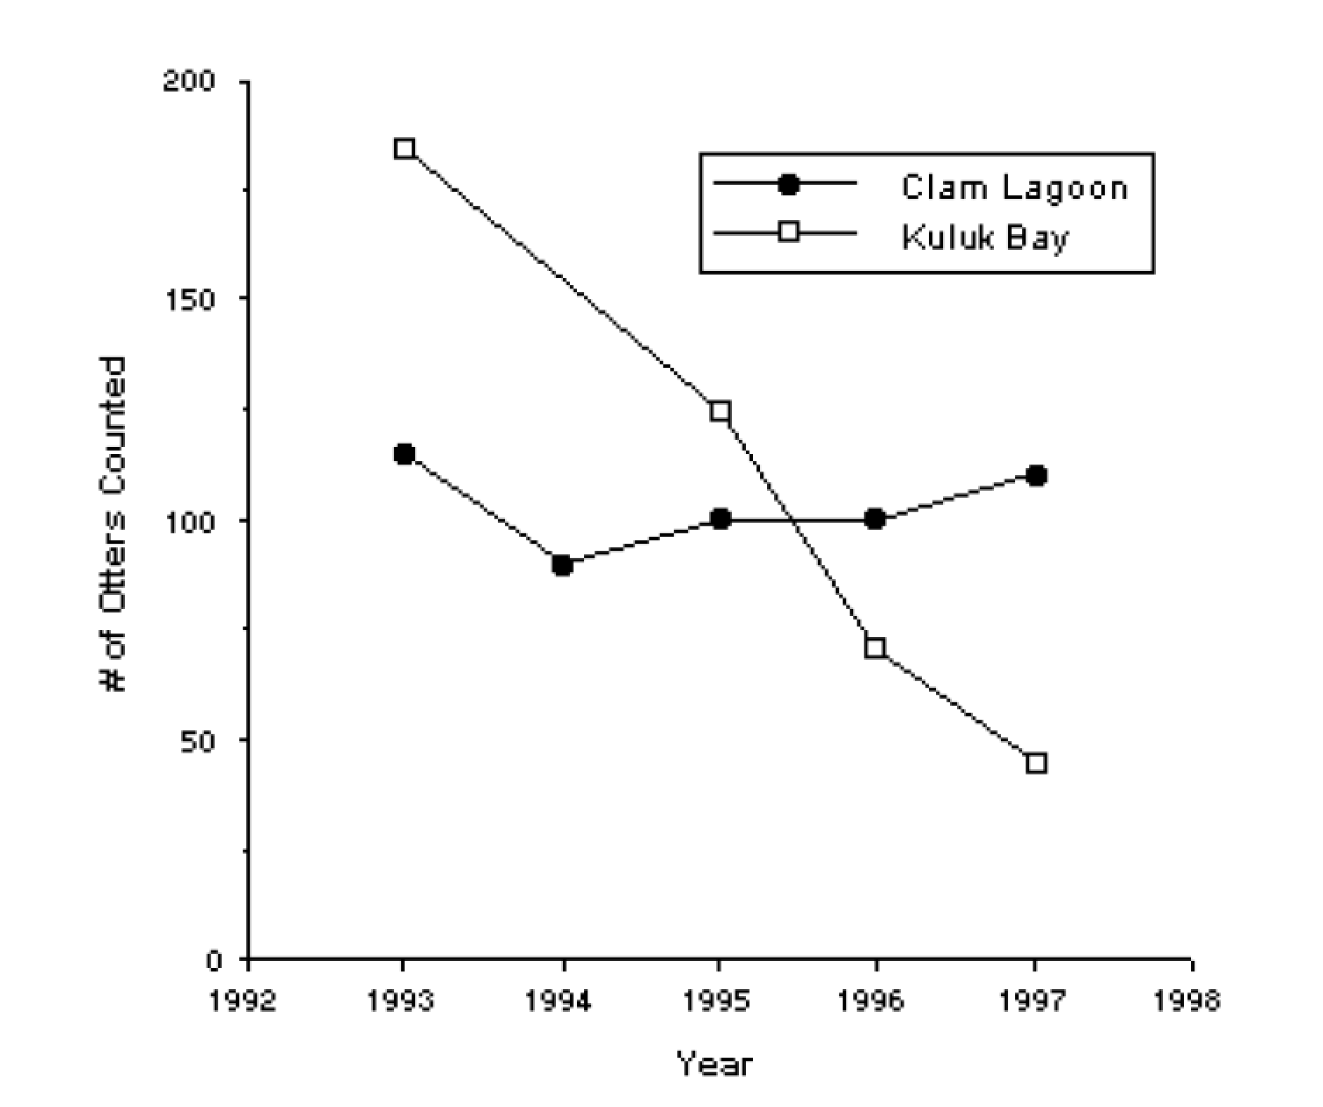

The research Estes and his colleagues performed estimated the impact of orcas on sea otter populations by comparing trends in population size and survival rates of individually marked otters between two adjacent locations on Adak Island: Clam Lagoon, and Kuluk Bay. Kuluk Bay is on an open coast, where sea otters are exposed to orcas. In Clam Lagoon, the entrance from the open sea is too narrow and shallow for orcas to pass through, affording protection to otter populations.

Survival rates of sea otters individually marked with flipper tags and radio transmitters at Clam Lagoon and Kuluk Bay, Alaska.

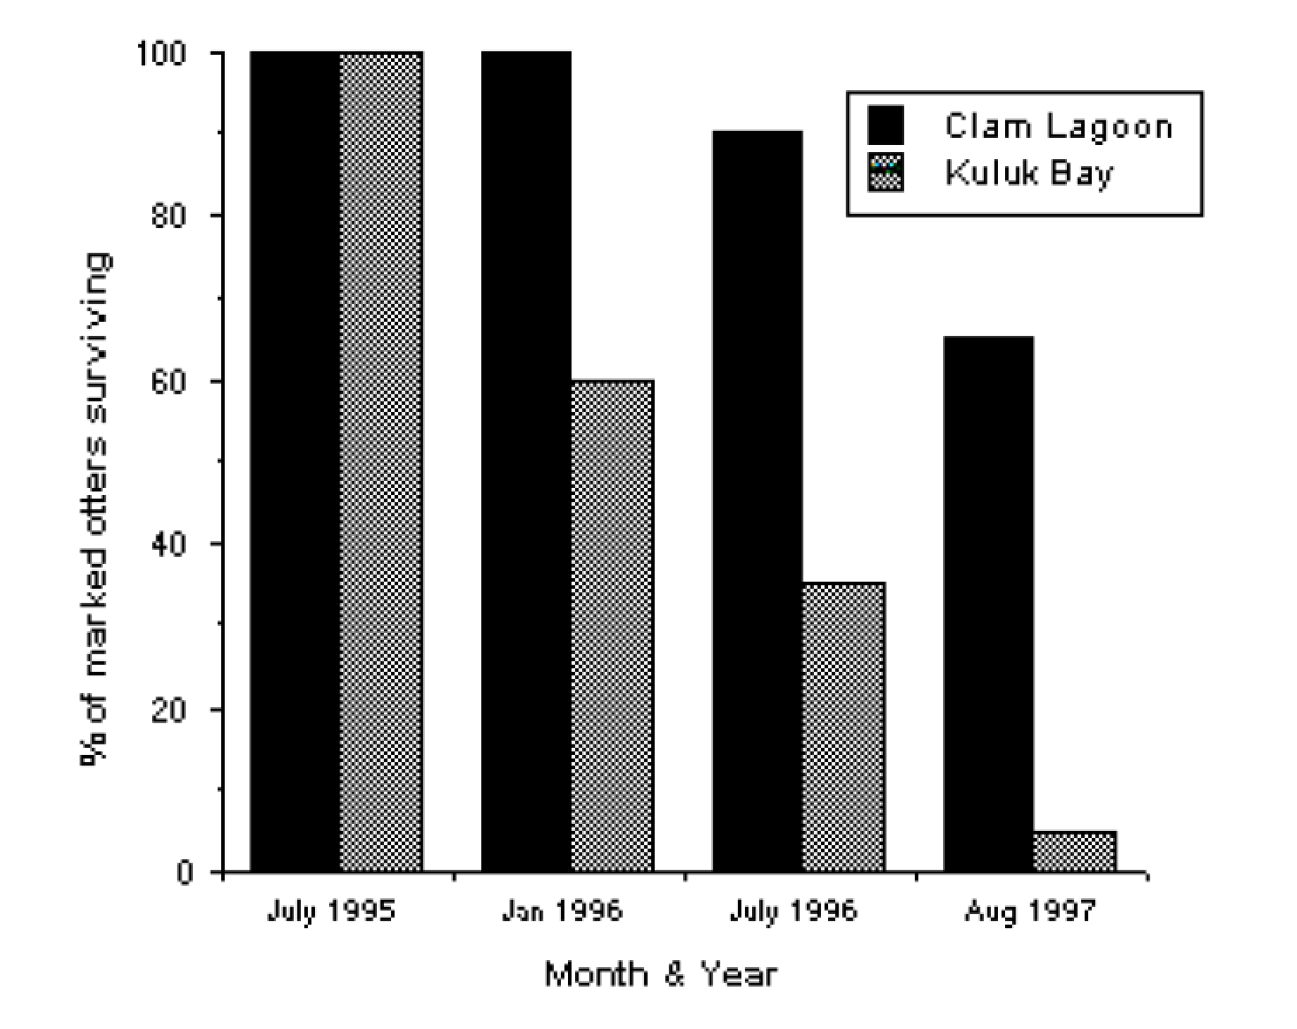Take a look at these results of their study:

**Q: In your own words, interpret the results of this graph.**

Changes in sea otter population size over time at Clam Lagoon and Kuluk Bay, Alaska.

**Q: What does this lead you to conclude about Estes’ hypothesis? Does there appear to be a connection between orcas and sea otter declines?**

Evidence points to orcas as the cause of sea otter decline, but prior to the 1990s, orcas and sea otters appear to have co-existed peacefully for decades. What could cause orcas to start preying upon sea otters?

Orcas, also called killer whales, are the largest members of the dolphin family (Delphinidae). Their diets are enormously varied: they prey upon squid, fish, birds, sea turtles, seals, sea lion pups, and dolphins. Groups of orcas may also collectively hunt larger animals, such as the blue whale. Orcas live in groups called pods, which are of at least two genetically, morphologically, and behaviorally distinct types: transient populations, that roam over broad areas of ocean and consume mostly mammals; and resident populations, that have smaller ranges and eat mostly fish. Under the assumption that orcas have begun to use otters as a food source, Estes suggested the following chain of events leading to this behavioral change:

~ Composition of fish species in the Bering Sea has changed dramatically in recent decades. Oily fish species such as ocean perch and herring have declined, while less oily fishes such as pollock have increased. Possible causes include:

* Overfishing
* 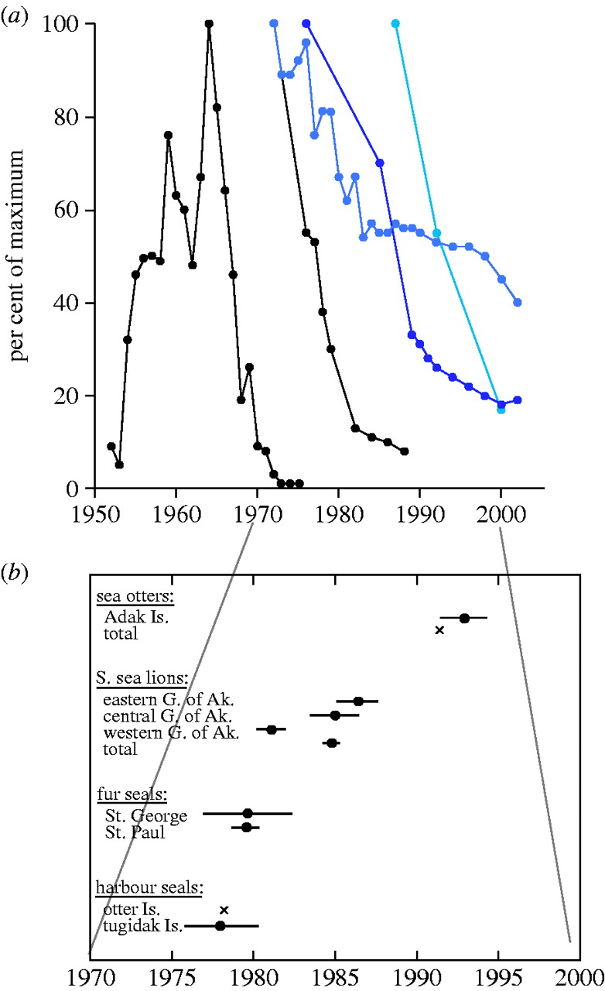Rising ocean temperatures in the northern Pacific
* Hunting of large plankton-feeding baleen whales,   
  which allowed plankton populations to increase.   
  This favors plankton-feeding fish, including pollock.

~ The decline in oily fish is a likely contributor to the collapse of Steller sea lion and harbor seal populations in the North Pacific, which had declined by as much as 80 percent by 1990. While pollock are available as an alternate food source, they are not as nutritious, particularly for growing juvenile pinnipeds.

Time series (L to R) of population change of great whales, harbour seals, northern fur seals, Steller sea lions and sea otters in the North Pacific Ocean and southern Bering Sea (from Springer et al. 2003)

~ Seals and sea lions are the major food source for transient orcas. Faced with a shortage of their normal prey, orcas may have switched to hunting otters, instead.

In addition to the trophic relationships we’ve explored up above, it turns out an even wider variety of organisms are affected by the collapse of kelp forest ecosystems. When otters are lost from a system:

* The growth rates of filter-feeding barnacles and mussels decline two- to threefold
* Population density of the rock greenling, a common kelp forest fish, declines approximately 10-fold
* The diet of glaucous-winged gulls shifts from fish to invertebrates
* The diet of bald eagles shifts from approximately equal parts fishes, birds, and mammals to domination by marine birds
* The density of starfish populations declines one to two orders of magnitude
* Reduced abundance of starfish, which are important predators in their own right, reduces the intensity of predation on invertebrates including the sea urchin.

When we consider that the loss of otters in kelp forests can cause a trophic cascade in those ecosystems that affects not only marine creatures, but birds as well, it becomes clear how complex and interconnected these feeding relationships are on a very large scale.

You will now revise your food web chart, to include this new development: orcas using otters as prey. Add this dynamic to your matrix chart, and make any necessary changes to the food web chart. In particular, you will want to change the “Top Down” arrows. Sketch your revised food web below:

*Adapted from an exercise written by Mary E. Allen and Mark L. Kuhlmann*