**Climate and Biomes**

Name(s) ____________________________________________

**Part A: Introduction to Biomes**

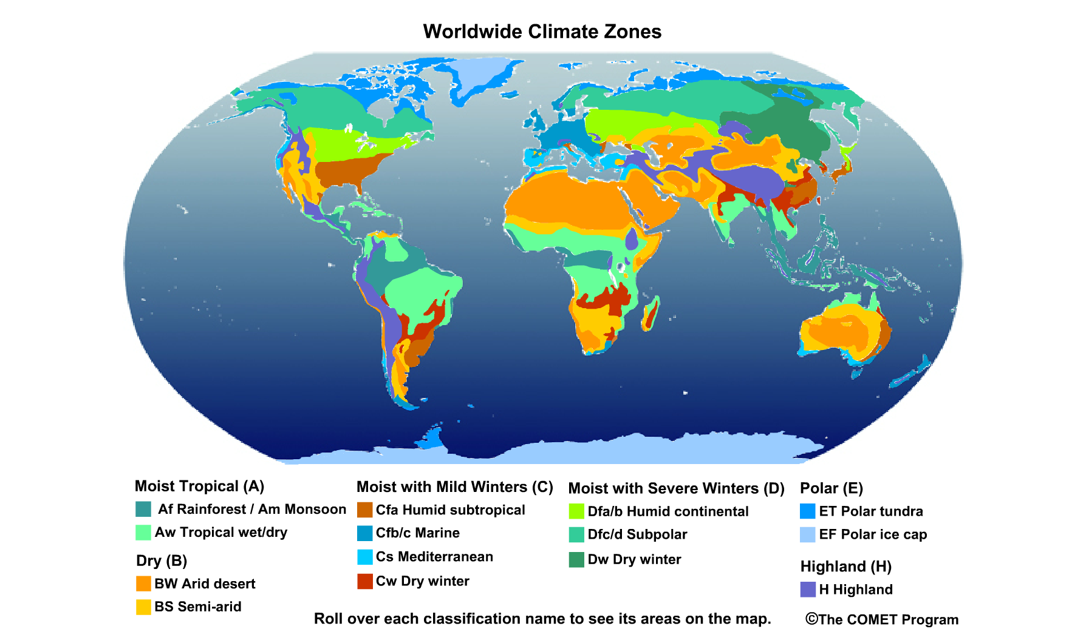

Examine the interactive rollover map at <http://serc.carleton.edu/eslabs/weather/4a.html> and look for climate and biome patterns. While investigating the map, rollover the titles in the legend to select regions, or groups of regions, one at a time. Look for patterns such as:

* Do certain zones appear along coasts?
* Are they in the interior of a continent?
* Are they located north or south of the equator?

Use the map and legend to answer the questions below:

1. In what general latitude bands, or sections of the map, are the deserts located?
2. Where are the moist tropical climates located? Do they seem to have a particular region within which they occur?
3. Where do you find the severe winter (extremely cold) climates?
4. What climate zone do you live in? Where else does it occur?

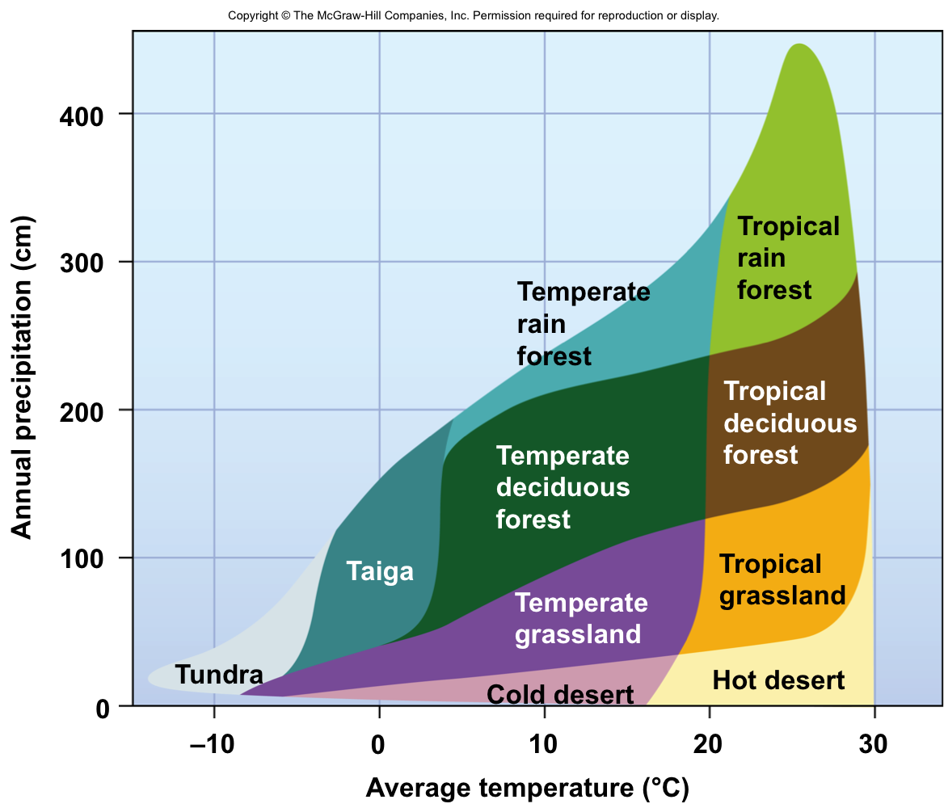Once you have located the biome in which you live, find it on the Whittaker Classification diagram:

1. What is the range of annual temperatures you can expect in this area?
2. What is the range of annual precipitation that can be expected?
3. Look to see what would happen if the average temperature in this area increased by 5˚C, and precipitation decreased by 25 cm per year? Compare the vegetation in the current biome to that of the new biome, and describe any shifts you might expect.

**Part B: Biomes and Climatology Comparison**

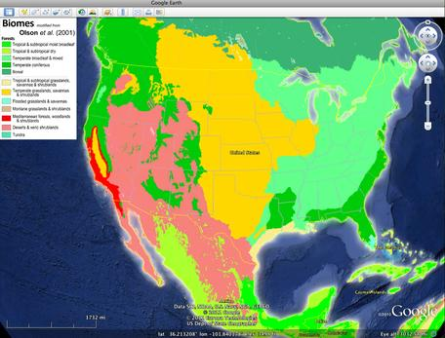

In this part of the lab you will work with Google Earth, a dynamic interactive map visualization tool. You will observe temperature patterns, biome types, and climatographs from selected cities around the world. As you work though the activity, keep in mind how climate, a long-term average of weather patterns, shapes the life of a region.

Google Earth is a free program that displays satellite images, aerial photographs, and graphic layers on personal computers by serving them over the Internet. If you already have Google Earth installed on your computer, you do not need to download and install another version; if not, you will want to install Google Earth Pro.

The project will open showing a map of the world. If this is your first time working with Google Earth, take time to practice turning layers on and off and using the navigation tools (Zoom and Move map) to move around the globe. The image below shows the flags indicating placemarks for the selected cities you will explore in this lab.

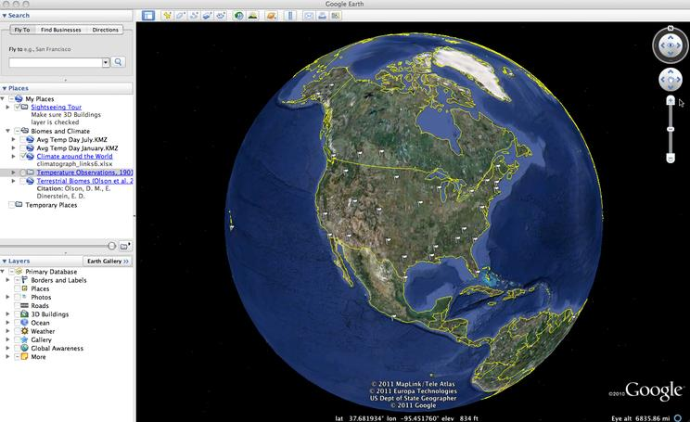

[creative commons]](http://serc.carleton.edu/details/images/28630.html)

**Explore temperature and geography**

Turn on the **Average Temperature (Day) for January** layer. This layer shows the average daytime temperature for the years 1970-2000. It may take a few seconds to load.

* Study the patterns of warm and cold areas on the globe
* Use the legend on the upper-left corner of the map to help you interpret the colors

When you are done exploring this layer, turn it off, and turn on the **Average Temperature (Day) for July**. Observe the differences in these two layers. When you are done investigating, turn off both of the Temperature layers.

Explore biomes and geography

Turn on the **Terrestrial Biomes** layer.

* Explore the locations of biomes around the globe. You may need to turn the Legend on and off for better viewing.
* With the Terrestrial Biomes layer selected (active), use the slider underneath the **Places** panel to make the layer more or less transparent.
* Use the Zoom and Move map tools to explore the relationship between biome types, elevation, and proximity to water bodies.

1. Note the patterns that emerge between biome type and geography. Record at least three patterns you observe:

Choose **View > Grid** to turn on the lines of latitude and longitude.

* Notice the areas where deserts are located and areas where it is especially rainy.

1. What geographical lines do these rainy regions fall between?

When you are done exploring, turn the globe to re-center the view on North America.

1. How do the biomes change as you go from west to east across the U.S.? Use your knowledge of regional climate forces to explain this pattern.

**Explore climate and geography**

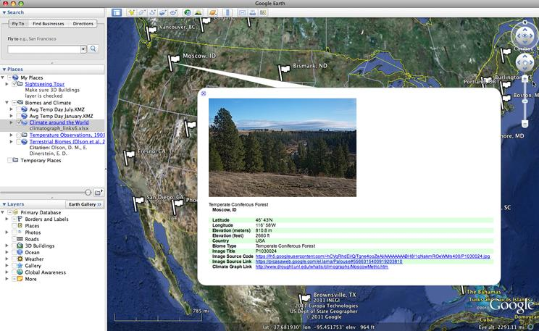Turn on the **Climate around the World** layer. You will see a number of white flags appear on the globe.

* Click on the flags to see images of the climate zones as well as links to climatographs of the cities.
* In the window that opens click the **climatograph link** to open a climatograph in a new browser window.

1. Choose three or more cities that are at similar latitudes across the country and compare their climate and biome type. (For example: San Diego, CA; Phoenix, AZ; Lubbock, TX; Jackson, MS; and Charleston, SC). Compare and contrast the three in the space below.
2. Now, choose two cities that share a line of longitude, and compare their climatographs. How does geographic variation affect these climate patterns?

**Part C: Design Your Own Continent**

# Continent of ___________________________________

90oN

60oN

30oN

0o

90oS

60oS

30oS

Wind

**A**

**B**

**C**

**D**

**F**

**E**

**H**



**G**

On the map of your hypothetical continent, indicate the location(s) of each of the following biomes: Tropical wet forest, Temperate rainforest, Grassland, Subtropical, Desert, Temperate forest, and Tundra.

Draw approximate boundary lines to delimit each biome type, and then label each delimited area with the type of biome it contains (feel free to color them appropriately). Consider the vegetation types and animal species that are likely to be found in each of these habitat zones. The following links have information that may be useful:

* <https://php.radford.edu/~swoodwar/biomes/#>
* <http://www.thewildclassroom.com/biomes/>

|  |  |  |  |
| --- | --- | --- | --- |
| **Point on the map** | **Biome type** | **Predominant Vegetation** | **Predominant Fauna** |
| A |  |  |  |
| B |  |  |  |
| C |  |  |  |
| D |  |  |  |
| E |  |  |  |
| F |  |  |  |
| G |  |  |  |
| H |  |  |  |

**Follow up Questions:**

1. Would the climate at point G be relatively wet or dry? Explain.
2. Is there any part(s) of the continent that would likely experience a rain shadow effect? Explain where a rainshadow would occur, and what causes it.
3. How are the general characteristics of plants (for example, morphology) influenced by climate? In other words, explain what effects climate has on the types of plants that grow in an area.

1. Finally, imagine if a large asteroid were to hit the Earth, and change its axis tilt from 23.5° to 10°.
   1. What effects would this have on seasons in the Northern Hemisphere?
   2. What effects would this have on biome distribution in the Northern hemisphere? In the diagram below, sketch out your hypothesis about where biomes would be located after the asteroid strike.

